# User manual for Pick up the crew

# Welcome

Welcome to pick up the crew! A game about Captains, Sharks and shipmates! The crew of the good ship “Sink Easy” have all gone overboard. It is the captain’s job to rescue them all. Unfortunately the seas have become infested with sharks that seem to have picked up a taste for ships. Can you rescue the crew without being eaten by a shark?

# Running the game

To run the game, please ensure you have a copy of Microsoft visual studio installed onto your computer. After visual studio has been installed, open the folder named “Pick up the crewV2” and double click the “PickUpTheCrew” solution file. This will bring up the source code for the game. Do not change anything in the code otherwise it will not compile and play. At the top of the page, there will be a green start button that looks like this:



To start playing the game, left click on this button or hit f5. This will take you to the title screen.

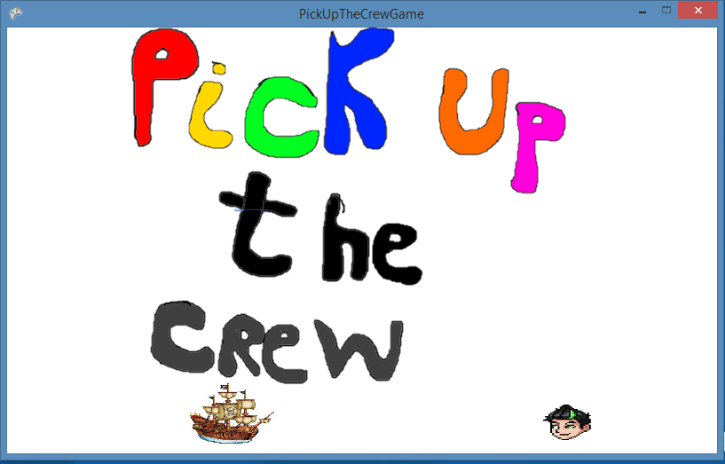

When you are ready to play the game, pressing the space bar will start the game and take you to the first level

# Playing the game

# Gameplay

# Movement

To navigate the captain through the perilous shark infested waters on his heroic rescue mission you must use the arrow keys on the keyboard. This will navigate the captain’s ship in the appropriate direction and speed. The ship cannot escape the tide. If the captains ship moves off the edge, the current will push him back to the sea. However, be warned! Navigating to close to a shark will result in the shark waking up and chasing the ship!

# Rescuing your shipmates

The object of the game is to rescue your shipmates from deadly shark infested waters. As you enter level one, your shipmates will automatically be placed on the screen.

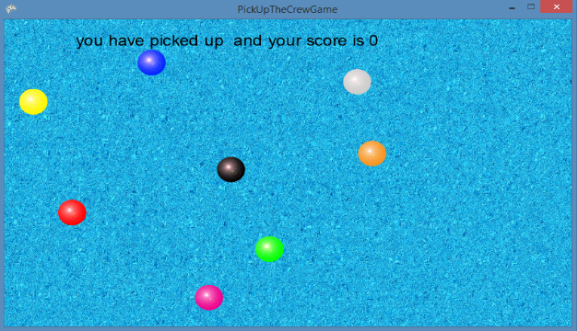

Picking up the crew member will result in that crew member no longer being visible on the screen and a total of a hundred points being added to your score. In addition, the name of the crew member will be displayed at the top of the screen, along with the total score from the game session. To progress to the next level, the Captain must pick up all of his shipmates and escape the waters by moving to any edge of the screen whilst avoiding the shark. When this happens, you will be taken to the next level.

# Heavy crew

Captain be warned! As you rescue more crew members, they increase the weight of the ship will slow down the overall speed of the ship. However, the deadly Sharks speed will always remain constant. Be mindful of your movements if you hope to beat the level!

# Saving and loading

After the first level has been completed, you will have the option to save the game and load it back in at a later date. At any point of the second level onwards, simply press the “S” key on the keyboard. This will save the game and exit the game. To load, simply repeat the steps in running the game and press the “L” key at the title screen. This will take you back to exactly the same point as you left. Be warned! If the shark is chasing you at the point of save, it will still be chasing you when you load the game.

# Levelling up

Once the captain has rescued his crew and escaped, you will be taken to the next level screen.

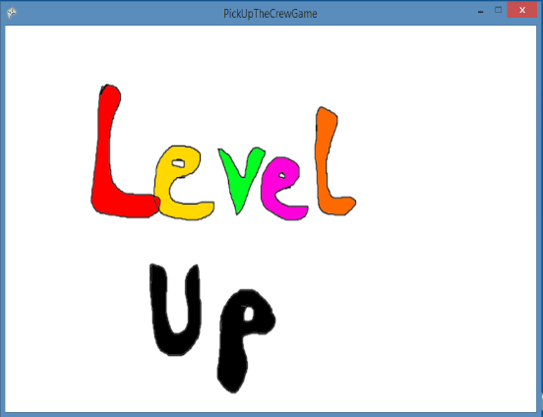

Once you are at this screen, it will give you a chance to take a breather from the high octane action! When you are ready, pressing space bar will take you to the next level, only this time, a new shark will be added and the crew will be in different positions on the screen.

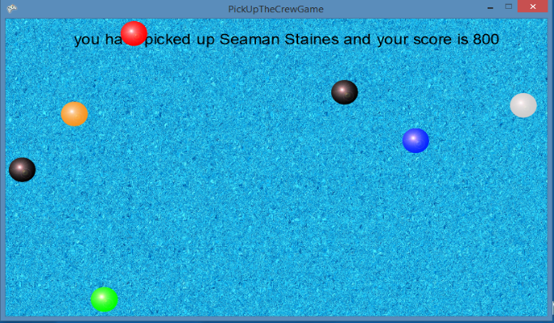

Can you survive the harder difficulty?

# Game Over

If at any point the Shark catches up with the captain and touches the ship, the game is over.

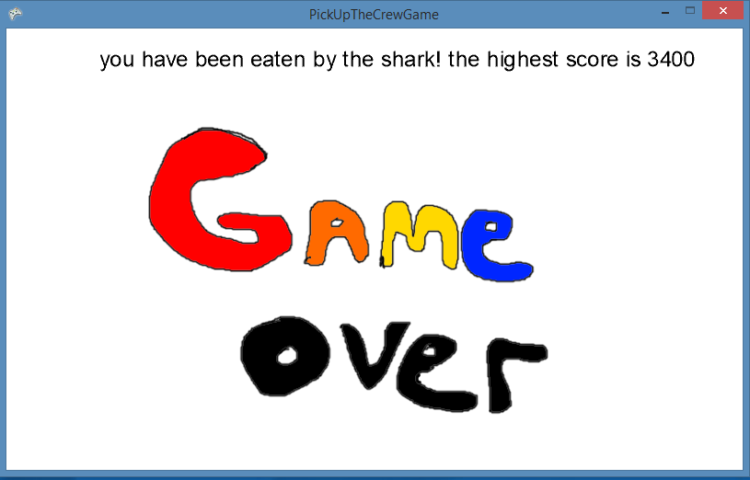

If you have set a high score it will be displayed at the top of the screen. This will be saved every time you load up the game. After approximately five seconds, the game will automatically revert back to the title screen giving you the opportunity to play again and try to beat the high score.

# Credits

Original concept and art work – Rob Miles

Lead programmer – Adam Deere

Sound effects gathered from - <http://www.freesfx.co.uk/sfx/pirate?p=3>

Title Song – Alestorm, “Wolves of the sea” from the 2009 album “Black sails at midnight (Napalm records). Used with permission